Disqus | Project Report

Group Number: 8



**Database**

**Management**

**Systems**

# Project Report

End Semester Project Title: Disqus

**Project members:**

|  |  |
| --- | --- |
| **Haris Lateef** | 287137 |
| **Muhammad Uzair Akhtar** | 283723 |
| **Muhammad Sarim Azeem** | 285825 |

**Table of Contents:**

Project members: ............................................................................................................................ 2

1. Introduction:......................................................................................................................... 4
   1. Purpose ............................................................................................................................. 4
   2. Project Scope .................................................................................................................... 4
2. System Features ..................................................................................................................... 4
   1. Requirement 1: ................................................................................................................. 4
   2. Requirement 2: ................................................................................................................. 4
   3. Requirement 3: ................................................................................................................. 5
   4. Requirement 4: ................................................................................................................. 5
3. Information Flow: .................................................................................................................. 5
4. EERDiagram:..........................................................................................................................6
5. Relational Schema: ..................................................................................................................7
6. SQL Queries for Creation of Tables and Constrains: ............................................................8
   1. Users Table: ..................................................................................................................... 8
   2. Tags Table: ...................................................................................................................... 8
   3. Reputation Table: ............................................................................................................ 8
   4. Threads Table: ................................................................................................................. 9
   5. Edit Suggestion Table: .................................................................................................... 9
   6. Link Table: ....................................................................................................................... 9
   7. Thread Comments Table: .............................................................................................. 10
   8. User Thread Tag Table: ................................................................................................ 10
   9. Votes Table: ................................................................................................................... 11
   10. Notification Table: ......................................................................................................... 11
7. SQL Queries for Data Insertion: ......................................................................................... 11
   1. Tags Table: .................................................................................................................... 12
   2. Reputation Table: .......................................................................................................... 12
   3. Thread_comments Table: .............................................................................................. 12
   4. Threads Table: ............................................................................................................... 13
   5. User_thread_tag: ........................................................................................................... 14
   6. Users Table: ................................................................................................................... 15
   7. Votes Table: ................................................................................................................... 15
   8. Edit_suggestions Table: ................................................................................................ 16
   9. Notification Table: ......................................................................................................... 16
8. Reports: .............................................................................................................................. 16
   1. Reputation from Top to bottom:..................................................................................... 16
   2. Most Up-Voted Thread: ................................................................................................. 17
   3. User-Wise Accepted Answer: ........................................................................................ 17
   4. Dead Thread Having no comment: ................................................................................ 17
   5. Question Wise Report: ................................................................................................... 17
   6. User with Most Answers (Most active user) ............................................................... 18
   7. Topic with Most Posted Threads.................................................................................. 18
   8. Most Down-Voted Thread ............................................................................................ 18
   9. Total no. of Edits by any admin (Admin with Max Edit Also) ..................................... 18
   10. Question-Wise Edits (Filtered on basis on Admin-Name, Edit Differences, Same multiple edits.) .......................................................................................................................... 19
9. Modification and Deletion of Data: .................................................................................... 19
   1. Query to change the datatype of column ‘token_id’ of ‘users’ table: ............................ 19
   2. Query to change the datatype of column ‘type’ of ‘user_thread_tag’ table: .................. 19
   3. Delete data from Table ‘tags’ where ‘tag_name’ is ‘c++’: ............................................ 19
   4. Delete data from Table ‘threads’ where ‘thread_user_id’ is 4: ...................................... 19
   5. Update information of a user:......................................................................................... 20
10. Front end: ........................................................................................................................... 20

# 1. Introduction:

## 1.1 Purpose

Mainly, this project is intended for educational purposes. The goal of this project is to practice the rules and architecture of database as well as to practice the rules of android development so as to gain understanding about real-world applications and their database structure.

## 1.2 Project Scope

This application is generally intended for developers and programming community so that they can interact with each other remotely and discuss their queries as well as to share their ideas*.*

# 2. System Features

## 2.1 Requirement 1:

* This application should consist of a login and Sign Up Page. Sign up is done using PHP login page and token ID obtained from API is stored in database.

* After login the user is shown some tags according to his interests and then threads related to his selected tags is shown on his feed. A tag actually describes the category

* If a user does not select any categories in the beginning, then he she is shown randomized feed. User is still able to add categories later on and hence filter his field according to his interests.

## 2.2 Requirement 2:

* There are two types of User. i.e. Regular User and Admin User. A user has a unique ID, location, Name, Profile Image URL. A user can up vote or down vote any post. A user is registered with a unique token and have account data store in the database.

* Regular User is able to create as many threads as want about any topic but a user can create at most only one post in a single day. A thread consists of text, image and Link to any other related website. A user can edit or delete his thread.

* A user can up vote and down vote on any thread or any comment at most once. The owner reputation is increased by one if anyone up votes his comment but in case the owner of the post up vote it then it will be increase by 5.

* A user can comment on any thread including his own. A user can also reply to any comment on any thread.

## 2.3 Requirement 3:

* Admin can perform all the tasks that a normal user can perform. In addition to that an admin can delete any post that contains any irrelevant content.

* Admin can also restrict any user’s account if he found the content of the thread irrelevant. Also he has the authority to again activate the account of the user.

* Admin can also suggest an edit to a thread. If the owner of the thread accepts it then the content of the thread will be changed.

## 2.4 Requirement 4:

* User can receive notifications related to only his thread. User can receive notification of reaction on his post. User can receive notification of any comment on his thread. User can receive notification of any reply on his comment.

**3.**

**I**

**information Flow:**

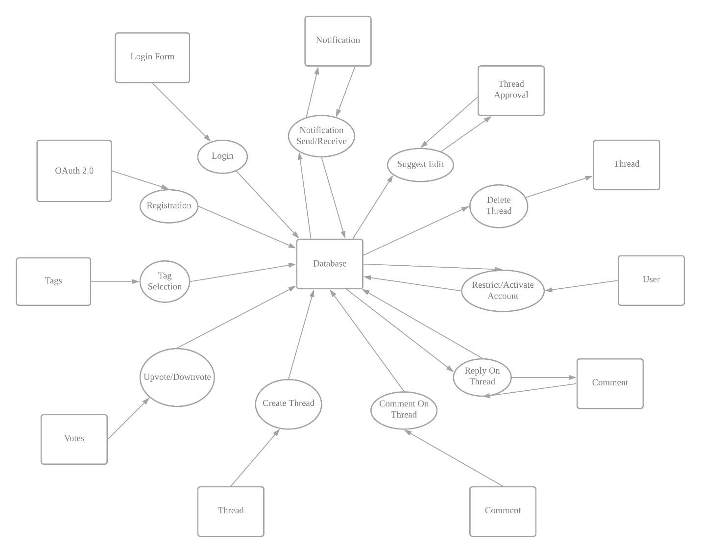

# 4. EER Diagram:

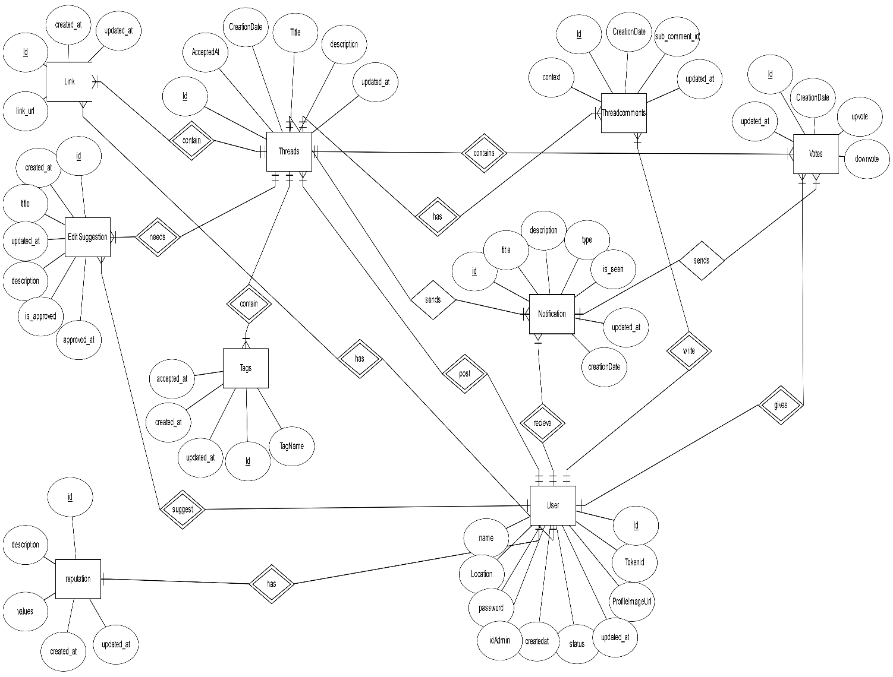

# 5. Relational Schema:

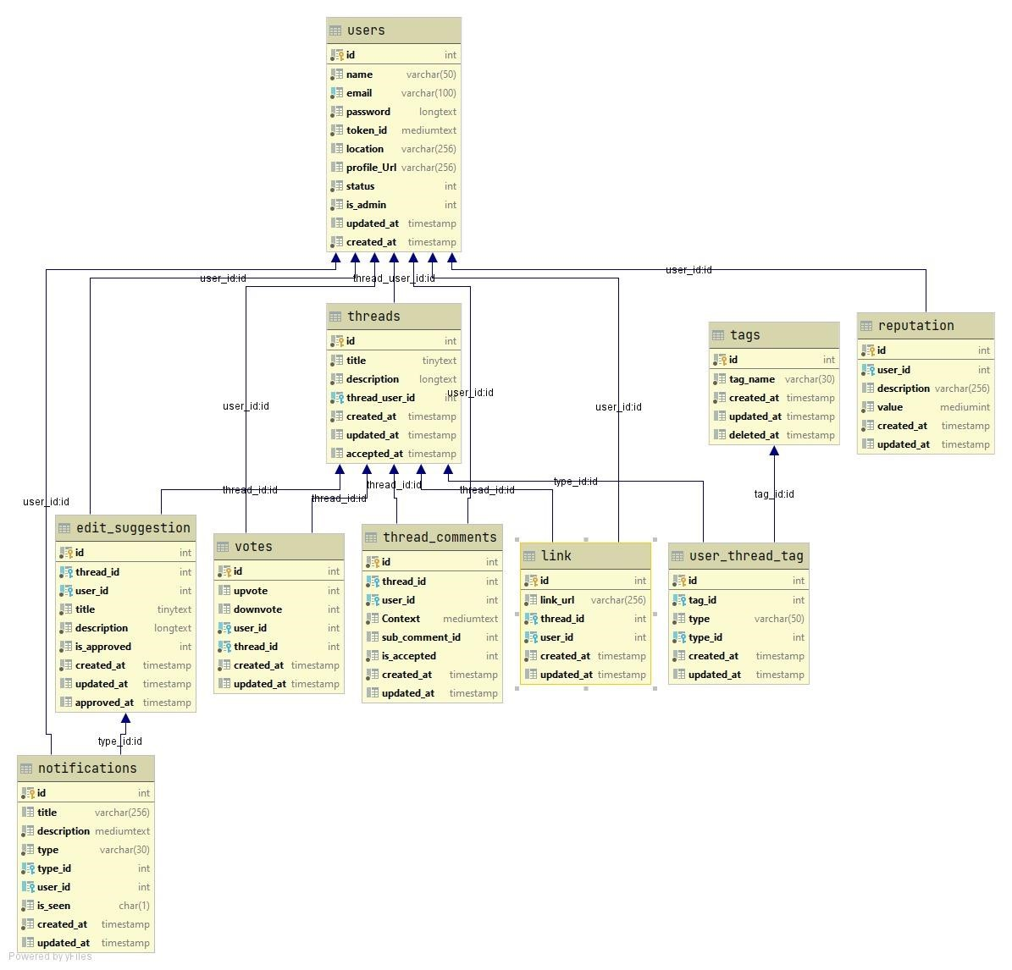

# 6. SQL Queries for Creation of Tables and Constrains:

## 6.1 Users Table:

create table users

(

id int auto_increment primary key,

name varchar(50) not null, email varchar(100) not null, password longtext not null, token_id mediumtext not null, location varchar(256) null, profile_Url varchar(256) null, status int default 0 not null, is_admin int default 0 not null, updated_at timestamp null, created_at timestamp default *CURRENT_TIMESTAMP* not null, constraint users_email_uindex unique (email)

);

## 6.2 Tags Table:

create table tags

(

id int auto_increment primary key,

tag_name varchar(30) not null, created_at timestamp default *CURRENT_TIMESTAMP* not null, updated_at timestamp null, deleted_at timestamp null );

## 6.3 Reputation Table:

create table reputation

( id int auto_increment primary key,

user_id int not null, description varchar(256) null, value mediumint not null, created_at timestamp default *CURRENT_TIMESTAMP* not null, updated_at timestamp null, constraint reputation_users__fk

foreign key (user_id) references users (id) on update cascade on delete cascade );

## 6.4 Threads Table:

create table threads

(

id int auto_increment primary key,

title tinytext not null, description longtext not null, thread_user_id int not null, created_at timestamp default *CURRENT_TIMESTAMP* not null, updated_at timestamp null, accepted_at timestamp null, constraint user_id

foreign key (thread_user_id) references users (id) on update cascade on delete cascade

);

## 6.5 Edit Suggestion Table:

create table edit_suggestion

(

id int auto_increment primary key,

thread_id int not null, user_id int not null, title tinytext not null, description longtext not null, is_approved int default 0 not null, created_at timestamp default *CURRENT_TIMESTAMP* not null, updated_at timestamp null, approved_at timestamp null, constraint edit_suggestion_threads__fk foreign key (thread_id) references threads (id) on update cascade on delete cascade, constraint edit_suggestion_users__fk foreign key (user_id) references users (id) on update cascade on delete cascade

);

## 6.6 Link Table:

create table link

( id int auto_increment primary key,

link_url varchar(256) not null, thread_id int not null,

user_id int not null, created_at timestamp default *CURRENT_TIMESTAMP* not null, updated_at timestamp null, constraint link_threads__fk

foreign key (thread_id) references threads (id) on update cascade on delete cascade, constraint link_users__fk

foreign key (user_id) references users (id) on update cascade on delete cascade

);

## 6.7 Thread Comments Table:

create table thread_comments

(

id int auto_increment primary key,

thread_id int not null, user_id int not null, Context mediumtext not null, sub_comment_id int null, updated_at timestamp null, created_at timestamp default *CURRENT_TIMESTAMP* not null, constraint thread_comments_threads__fk foreign key (thread_id) references threads (id) on update cascade on delete cascade, constraint thread_comments_users__fk foreign key (user_id) references users (id) on update cascade on delete cascade

);

## 6.8 User Thread Tag Table:

create table user_thread_tag

( id int auto_increment primary key,

tag_id int not null, type varchar(50) not null, type_id int not null, created_at timestamp default *CURRENT_TIMESTAMP* not null, updated_at timestamp null, constraint user_thread_tag_tags__fk foreign key (tag_id) references tags (id) on update cascade on delete cascade, constraint user_thread_tag_users__fk foreign key (type_id) references users (id) on update cascade on delete cascade, constraint user_thread_tag_threads__fk

foreign key (type_id) references threads (id) on update cascade on delete cascade

);

## 6.9 Votes Table:

create table votes

(

id int auto_increment primary key,

upvote int null, downvote int null, user_id int not null, thread_id int not null, created_at timestamp default *CURRENT_TIMESTAMP* not null, updated_at timestamp null, constraint votes_threads__fk

foreign key (thread_id) references threads (id) on update cascade on delete cascade, constraint votes_users__fk

foreign key (user_id) references users (id) on update cascade on delete cascade

);

## 6.10 Notification Table:

create table notifications

(

id int auto_increment primary key,

title varchar(256) null, description mediumtext not null, type tinyint not null, type_id int not null, user_id int null, is_seen char default '0' not null, created_at timestamp default *CURRENT_TIMESTAMP* not null, updated_at timestamp null, constraint notifications_edit_suggest__fk foreign key (type_id) references edit_suggestion (id) on update cascade on delete cascade, constraint notifications_repu__fk

foreign key (type_id) references reputation (id) on update cascade on delete cascade, constraint notifications_thread_comment__fk foreign key (type_id) references thread_comments (id) on update cascade on delete cascade, constraint notifications_threads__fk foreign key (type_id) references threads (id) on update cascade on delete cascade, constraint notifications_users__fk

foreign key (user_id) references users (id) on update cascade on delete cascade, constraint notifications_vote__fk

foreign key (type_id) references votes (id) on update cascade on delete cascade );

# 7. SQL Queries for Data Insertion:

## 7.1 Tags Table:

insert into disqus.tags (id, tag_name, created_at, updated_at, deleted_at) values (1, 'node', '2021-01-01 18:28:33', null, null), (2, 'c++', '2021-01-01 18:28:33', null, null),

(3, 'cpp', '2021-01-01 18:28:33', null, null),

(4, 'console resources', '2021-01-01 18:28:33', null, null),

(5, 'error 520', '2021-01-01 18:28:33', null, null),

(6, 'error 404', '2021-01-01 18:28:33', null, null),

(7, 'Terminal Emulator', '2021-01-01 18:28:33', null, null),

(8, 'priority problem', '2021-01-01 18:28:33', null, null),

(9, 'react', '2021-01-01 18:28:33', null, null),

(10, 'kotlin', '2021-01-01 18:28:33', null, null),

(11, 'java', '2021-01-01 18:28:33', null, null),

(12, 'react native', '2021-01-01 18:28:33', null, null);

## 7.2 Reputation Table:

insert into disqus.reputation (id, user_id, description, value, created_at, updated_at)

values (1, 1, 'Trusted User', 30, '2021-01-02 11:12:28', null),

(2, 2, 'Established User', 11, '2021-01-02 11:12:28', null),

(3, 5, 'Access to Site Analytics', 100, '2021-01-02 11:12:28', null),

(4, 4, 'Unrestricted User', 70, '2021-01-02 11:12:28', null),

(5, 6, 'Trusted User', 30, '2021-01-02 11:12:28', null),

(6, 7, 'Established User', 11, '2021-01-02 11:12:28', null),

(7, 8, 'Access to Site Analytics', 100, '2021-01-02 11:12:28', null),

(8, 9, 'Unrestricted User', 70, '2021-01-02 11:12:28', null),

(9, 10, 'Access to Site Analytics', 100, '2021-01-02 11:12:28', null),

(10, 3, 'Unrestricted User', 70, '2021-01-02 11:12:28', null);

## 7.3 Thread_comments Table:

insert into disqus.thread_comments (id, thread_id, user_id, Context, sub_comment_id, updated_at, created_at)

values (1, 1, 3, 'You have to use cin.getline():', 0, null, '2021-01-02 11:03:07'),

(2, 1, 2, ' it happens. C++ isn''t exactly as intuitive as we would like it to be.', 1, null, '2021-01-02 11:03:07'),

(3, 1, 4, 'It doesn''t "fail"; it just stops reading. It sees a lexical token as a "string".', 0, null, '2021-01-02 11:03:07'),

(4, 2, 5, 'check your IP is enabled by mongodb atlas. you should give access to your computer IP address from mongodb atlas. go to the network access (left side bar) enter your IP or enter 0.0.0.0 to access all IP.', 0, null, '2021-01-02 11:03:07'),

(5, 2, 1, 'Did you have this line in your app.js app.use(cors())?',

0, null, '2021-01-02 11:03:07'),

(6, 3, 5, 'I think you are using chrome. The problem is the certificate mismatch or the expiration of the certificate.Check your certificate properly.', 0, null, '2021-01-02 11:03:07'),

(7, 3, 4, 'but i am getting this error on Mozilla also. What you think its just a browser isuue?', 6, null, '2021-01-02 11:03:07'), (8, 3, 5, 'its because of the certificate mismatch as i said', 7, null, '2021-01-02 11:03:07'),

(9, 4, 1, 'As quoted from CloudFlare''s Documentation:', 0, null, '2021-01-02 11:07:22'),

(10, 5, 4, 'The 404 code means that the server was unable to locate the files you were looking for via GET request.', 0, null, '2021-01-02

11:07:22'),

(11, 5, 5, 'just wondering what you mean by adding google maps api in tags? Has he not done that already?', 10, null, '2021-01-02 11:07:22'), (12, 5, 4, 'I made a mistake and mixed 1) and 2) in my rush to answer the question. He does use the script tags, but he forgot to include the text/javascript type.', 11, null, '2021-01-02 11:07:22'),

(13, 6, 5, 'The single fact that "then" is used after countDocuments does indicate that it''s a promise and thus asynchronous.', 0, null, '2021-

01-02 11:08:51'),

(14, 6, 2, 'It solved my problem. Thank you so much.', 13, null, '2021-01-02 11:08:51');

## 7.4 Threads Table:

insert into disqus.threads (id, title, description, thread_user_id, created_at, updated_at, accepted_at)

values (1, 'Input string in c++ with spaces', 'The user wants to enter "Hello World". But cin fails at the space between the two words. How can I make cin take in the whole of Hello World? I''m actually doing this with structs and cin.getline doesn''t seem to work. My code yields an error. Any ideas?', 1, '2021-01-01 18:10:06', null, null),

(2, 'Unable to connect to mongodb atlas with mongoose', 'I need help!!! I tried connecting to mongodb atlas with my connection string but

I''m unable to. I''m not sure how to proceed. i have a barebones application. I''m getting a connection error (a mongooseServerSelectionError) and an unhandled Promise Rejection Warning.', 2, '2021-01-01 18:10:06', null, null), (3, 'Getting error in console : Failed to load resource', 'I have refresh my application page and getting this error in console Failed to load resource: net::ERR_CONNECTION_RESET.', 4, '2021-01-01 18:10:06', null, null), (4, 'Some files returning Error 520', 'Some of my files in my web server is returning Error 520: Web server is returning an unknown error. As far as I know, the files returning the errors are index.php and google0f3d9b***.html (used to verify Google Webmaster Console).', 5, '202101-01 18:10:06', null, null),

(5, 'What is meaning of error 404 (Not Found)', 'I have created a small web site, where I am showing some data, which I get from an API (JSON data type). In my console I am getting these two errors:', 5, '2021-01-01

18:10:06', null, null),

(6, 'How To Solve NodeJS Method Priority Problem', 'In this case, method 3 works first and i am getting error. Its priority has to be like method 1, method 2, and method 3. Are these methods promises ? And promises work as asynchronous.', 2, '2021-01-01 18:10:06', null, null),

(7, 'Failed to launch preferred application for category

TerminalEmulator. Could not find fallback TerminalEmulator application', 'I see others have the the issue and see some resolution. And my questions is where to I run that install command from if I can''t get to terminal to run it? Thanks', 4, '2021-01-01 18:13:52', null, null),

(8, 'Where is the error in the react?', 'I built the file using commands: browserify -t reactify js/app.js -o js/build.js When starting in the browser, an error occurs: build.js:196 Uncaught TypeError: React.render is not a function at Object.2.react (build.js:196) at s (build.js:1) at e (build.js:1) at build.js:1', 6, '2021-01-01 18:10:06', null, null),

(9, 'How to avoid StackOverFlow error in Java/Kotlin/IntelliJ IDEA?',

'I want to do a factorial of a BigInteger (in Kotlin). With a tail recursion

I get StackOverFlow error when I try to do 9000! . With a non-recursive function I can do that ... but I am very curious how to avoid this kind of error.', 7, '2021-01-01 18:10:06', null, null),

(10, 'How to use My Fragment TextViews and button from my Activity?', 'I have asked similar questions here before How to make my Fragment make use of my Activity Data? and How to send data from Activity to Fragment?(Android) But it seems that most people did not quite understand what I mean, so let me explain better. Suppose I have a Textview and a button.', 9, '2021-01-01

18:10:06', null, null),

(11, 'Will Expo notifications work after project is built?', 'I am building a React Native app with Expo, and I am using Expo Notifications. If I go to build this app on iOS and Android, will Expo Notifications still work on the built app? Or is this something that only works so long as the app runs on Expo?', 8, '2021-01-01 18:10:06', null, null);

## 7.5 User_thread_tag:

insert into disqus.user_thread_tag (id, tag_id, type, type_id, created_at, updated_at)

values (1, 1, 'User', 1, '2021-01-02 10:55:45', null), (2, 2, 'User', 1, '2021-01-02 10:55:45', null),

(3, 3, 'User', 1, '2021-01-02 10:55:45', null),

(4, 4, 'Thread', 2, '2021-01-02 10:55:45', null),

(5, 5, 'Thread', 2, '2021-01-02 10:55:45', null),

(6, 6, 'Thread', 2, '2021-01-02 10:55:45', null),

(7, 7, 'Thread', 2, '2021-01-02 10:55:45', null),

(8, 8, 'Thread', 2, '2021-01-02 10:55:45', null),

(9, 1, 'User', 1, '2021-01-02 10:55:45', null),

(10, 2, 'Thread', 2, '2021-01-02 10:55:45', null),

(11, 3, 'User', 1, '2021-01-02 10:55:45', null), (12, 4, 'Thread', 2, '2021-01-02 10:55:45', null);

## 7.6 Users Table:

insert into disqus.users (id, name, email, password, token_id, location, profile_Url, status, is_admin, updated_at, created_at) values (1, 'Saqib Rasheed', 'msaqib@gmail.com',

'$2y$10$c3SwLIb60ywA6MouTH50wexYfYCo.WtZLbqDC1e2zR816MiiRHTuO', '1',

'Islamabad', 'saqibrasheed', 1, 0, null, '2021-01-01 17:43:49'),

(2, 'Muhammad Ahmad', 'ahmad@gmail.com',

'$2y$10$lGgMaf0gJwztcev7uF/Vm.7IP0hT4f1cD7X7kOruWFHdZbEfd0JMa', '2',

'Faisalabad', 'ahmad62', 1, 0, null, '2021-01-02 17:43:49'),

(3, 'Shehryar Amin', 'sharry@gmail.com',

'$2y$10$JThm6hmw6/SzfRhGvWiB1eCltcMA8lJPsa1H/zfbvykWvQWwGrLPS', '3',

'Gujrat', 'sharry', 1, 1, null, '2021-01-01 17:43:49'),

(4, 'Abdul Baari', 'baari@gmail.com',

'$2y$10$opjhG4K4dnFNHtAK20W48uaUpAKVI4qL9GJym4fxWHS8kwqeZ3P.2', '4',

'Vehari', 'baari', 1, 0, null, '2021-01-01 17:46:09'),

(5, 'Hammad Mukhtar', 'hammad@gmail.com',

'$2y$10$V8DPOquMiMfubemsWxsUXetsDmgiWMJlMkpXzdY1GUjVNUNjdVr1q', '5',

'Multan', 'hammad', 0, 0, null, '2021-01-01 17:46:09'),

(6, 'Angela Yu', 'angela@gmail.com',

'$2y$10$c3SwLIb60ywA6MouTH50wexYfYCo.WtZLbqDC1e2zR816MiiRHTuO', '1',

'London', 'angela', 1, 0, null, '2021-01-01 17:43:49'),

(7, 'Maxmilian', 'maxmil@gmail.com',

'$2y$10$lGgMaf0gJwztcev7uF/Vm.7IP0hT4f1cD7X7kOruWFHdZbEfd0JMa', '2',

'Berlen', 'max69', 1, 0, null, '2021-01-02 17:43:49'),

(8, 'Shuwarz Muller', 'shuwarz@gmail.com',

'$2y$10$JThm6hmw6/SzfRhGvWiB1eCltcMA8lJPsa1H/zfbvykWvQWwGrLPS', '3',

'Manila', 'shuwarz', 1, 0, null, '2021-01-01 17:43:49'),

(9, 'Steven Wolfe', 'steve@gmail.com',

'$2y$10$opjhG4K4dnFNHtAK20W48uaUpAKVI4qL9GJym4fxWHS8kwqeZ3P.2', '4', 'New

York', 'steve', 1, 1, null, '2021-01-01 17:46:09'),

(10, 'Usama Shoukat', 'kitkat@gmail.com',

'$2y$10$V8DPOquMiMfubemsWxsUXetsDmgiWMJlMkpXzdY1GUjVNUNjdVr1q', '5', 'Jhang', 'kitkat', 0, 0, null, '2021-01-01 17:46:09')

## 7.7 Votes Table:

insert into disqus.votes (id, upvote, downvote, user_id, thread_id, created_at, updated_at)

values (1, 123, 3, 1, 2, '2021-01-01 18:18:52', null), (2, 1102, 67, 2, 3, '2021-01-01 18:18:52', null),

(3, 328, 4, 3, 4, '2021-01-01 18:18:52', null),

(4, 3433, 56, 4, 5, '2021-01-01 18:18:52', null),

(5, 267, 32, 4, 6, '2021-01-01 18:18:52', null),

(6, 133, 13, 6, 2, '2021-01-01 18:18:52', null),

(7, 1202, 27, 7, 3, '2021-01-01 18:18:52', null),

(8, 358, 35, 3, 8, '2021-01-01 18:18:52', null),

(9, 3833, 66, 4, 9, '2021-01-01 18:18:52', null),

(10, 67, 72, 4, 6, '2021-01-01 18:18:52', null);

## 7.8 Edit_suggestions Table:

insert into disqus.edit_suggestion (id, thread_id, user_id, title, description, is_approved, created_at, updated_at, approved_at)

values (1, 2, 2, 'Unable to connect to mongodb atlas with mongoose', 'I need help!!! I tried connecting to mongodb atlas with my connection string but I''m unable to. I''m not sure how to proceed. i have a barebones application. I''m getting a connection error (a mongooseServerSelectionError) and an unhandled Promise Rejection Warning.', 0, '2021-01-02 11:27:17', null, null),

(2, 3, 4, 'Console errors. Failed to load resource:

net::ERR_INSECURE_RESPONSE', 'I have refresh my application page and getting this error in console Failed to load resource: net::ERR_CONNECTION_RESET.', 0, '2021-01-02 11:27:17', null, null);

## 7.9 Notification Table:

insert into disqus.notifications (id, title, description, type, type_id, user_id, is_seen, created_at, updated_at)

values (1, 'New Comment on your thread!', 'Muhammad Ahmad commented on your thread!', 'Comment', 2, 9, '0', '2021-01-13 00:07:30', null),

(2, 'New reply to your thread!', 'Muhammad Ahmad replied to your comment on Saqib Rasheed''s thread.', 'Reply', 1, 2, '0', '2021-01-13

00:07:30', null),

(3, 'New Comment on your thread!', 'Steve Wolf commented on your thread!', 'Comment', 2, 1, '0', '2021-01-13 00:07:30', null),

(4, 'New reply to your thread!', 'Shehryar Amin replied to your comment on Muhammad Ahmad''s thread.', 'Reply', 1, 2, '0', '2021-01-13

00:07:30', null),

(5, 'New Comment on your thread!', 'Angela Yu commented on your thread!', 'Comment', 2, 4, '0', '2021-01-13 00:07:30', null),

(6, 'New reply to your thread!', 'Maxmilian replied to your comment on Shuwarz Muller''s thread.', 'Reply', 1, 9, '0', '2021-01-13 00:07:30', null),

(7, 'New Comment on your thread!', 'Usama Shoukat commented on your thread!', 'Comment', 2, 5, '0', '2021-01-13 00:07:30', null),

(8, 'New reply to your thread!', 'Shehryar Amin replied to your comment on Angela Yu''s thread.', 'Reply', 1, 10, '0', '2021-01-13 00:07:30', null),

(9, 'New Comment on your thread!', 'Abdul Baari commented on your thread!', 'Comment', 2, 6, '0', '2021-01-13 00:07:30', null),

(10, 'New reply to your thread!', 'Saqib Rasheed replied to your comment on Hammad Mukhatar''s thread.', 'Reply', 1, 7, '0', '2021-01-13 00:07:30', null);

# 8. Reports:

## 8.1 Reputation from Top to bottom:

select

users.name, users.email, users.location,

r.value as 'Reputation',

r.description from users

join reputation r on users.id = r.user_id order by r.value DESC;

## 8.2 Most Up-Voted Thread:

select t.title,

t.description,

v.upvote,

v.downvote from threads t

join votes v on t.id = v.thread_id

where upvote in (SELECT *max*(upvote) from votes);

## 8.3 User-Wise Accepted Answer:

select u.name,

u.email,

u.location,

*count*(user_id) as 'Total Accepted Answers' from users u

join thread_comments tc on u.id = tc.user_id where is_accepted = 1 group by user_id

order by *count*(user_id) DESC;

## 8.4 Dead Thread Having no comment:

select t.title, t.description from threads t

left join thread_comments tc on t.id = tc.thread_id where tc.thread_id IS NULL; *#Join Query*

select title, description from threads

where id NOT IN (SELECT thread_id from thread_comments);

*# Nested Query*

## 8.5 Question Wise Report:

select

u.name,

u.email,

*count*(thread_user_id) as 'Total Asked Question',

t.title,

t.description from users u

join threads t on u.id = t.thread_user_id group by t.thread_user_id

order by *count*(thread_user_id) DESC;

## 8.6 User With Most Answers (Most active user)

select u.name,

u.email,

u.location,

*count*(user_id) as 'Total Answers' from users u

join thread_comments tc on u.id = tc.user_id group by user_id

order by *count*(user_id) DESC;

## 8.7 Topic with Most Posted Threads

select tag_name,

*count*(tag_id) as 'Total Threads' from tags

join user_thread_tag utt on tags.id = utt.tag_id join threads t on utt.type_id = t.id where type_id = 2 && type = 'Thread' group by tag_id

order by *count*(tag_id) DESC;

## 8.8 Most Down-Voted Thread

select t.title,

t.description,

v.upvote,

v.downvote from threads t

join votes v on t.id = v.thread_id where downvote IN (SELECT *max*(downvote) from votes);

## 8.9 Total no. of Edits by any admin (Admin with Max Edit Also)

## select

u.name as 'Admin Name',

u.email as 'Admin Email', *count*(thread_id) as 'No.of Edits'

from threads t

join edit_suggestion es on t.id = es.thread_id join users u on es.user_id = u.id group by u.id

order by *count*(thread_id) DESC;

## 8.10 Question-Wise Edits (Filtered on basis on Admin-Name, Edit Differences, Same multiple edits.)

select es.title as 'Sugg. Title', es.description as 'Sugg. Description', *count*(thread_id) as 'No.of Edits',

t.id as 'Thread ID',

u.name as 'Admin Name',

u.email as 'Admin Email' from threads t

join edit_suggestion es on t.id = es.thread_id join users u on es.user_id = u.id group by thread_id, u.id, es.title, es.description order by *count*(thread_id) DESC;

# 9. Modification and Deletion of Data:

## 9.1 Query to change the datatype of column ‘token_id’ of ‘users’ table:

alter table users modify token_id longtext

## 9.2 Query to change the datatype of column ‘type’ of ‘user_thread_tag’ table:

alter table user_thread_tag modify type mediumtext

## 9.3 Delete data from Table ‘tags’ where ‘tag_name’ is ‘c++’:

delete from tags where tag_name = "c++"

## 9.4 Delete data from Table ‘threads’ where ‘thread_user_id’ is 4:

delete from threads where thread_user_id = 4

## 9.5 Update information of a user:

update users set location = 'Islamabad' where id = 4

# 10. Front End:

